LAB08-IoT SW installation process
Class:M01
Student ID:B2111959
Name:Nguyen Thi Hoai Thuong
- Code:
Create file b2111959.sh
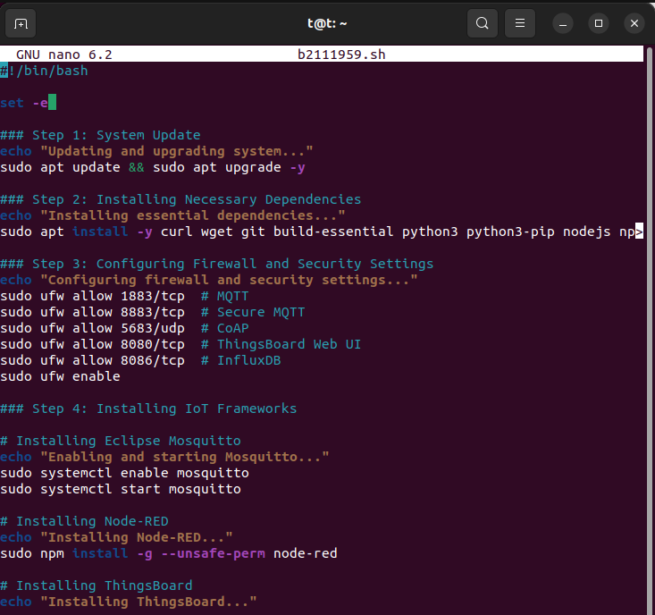
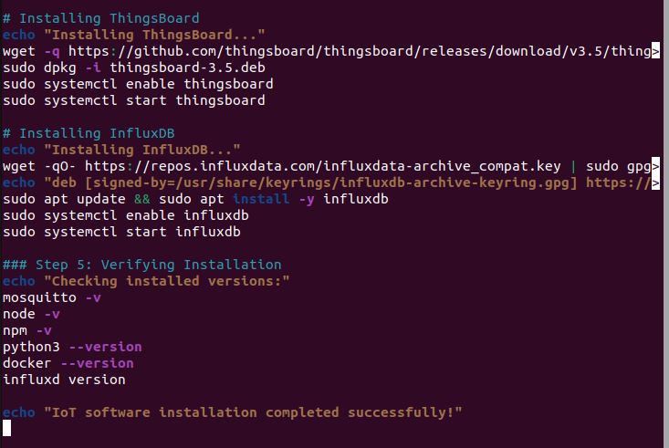
#!/bin/bash

set -e # Dừng script nếu có lỗi

### Step 1: System Update
echo "Updating and upgrading system..."
sudo apt update && sudo apt upgrade -y

### Step 2: Installing Necessary Dependencies
echo "Installing essential dependencies..."
sudo apt install -y curl wget git build-essential python3 python3-pip nodejs npm openssl ufw mosquitto mosquitto-clients docker.io docker-compose

### Step 3: Configuring Firewall and Security Settings
echo "Configuring firewall and security settings..."
sudo ufw allow 1883/tcp # MQTT
sudo ufw allow 8883/tcp # Secure MQTT
sudo ufw allow 5683/udp # CoAP
sudo ufw allow 8080/tcp # ThingsBoard Web UI
sudo ufw allow 8086/tcp # InfluxDB
sudo ufw enable

### Step 4: Installing IoT Frameworks

# Installing Eclipse Mosquitto
echo "Enabling and starting Mosquitto..."
sudo systemctl enable mosquitto
sudo systemctl start mosquitto

# Installing Node-RED
echo "Installing Node-RED..."
sudo npm install -g --unsafe-perm node-red

# Installing ThingsBoard
echo "Installing ThingsBoard..."
wget -q https://github.com/thingsboard/thingsboard/releases/download/v3.5/thingsboard-3.5.deb
sudo dpkg -i thingsboard-3.5.deb
sudo systemctl enable thingsboard
sudo systemctl start thingsboard

# Installing InfluxDB
echo "Installing InfluxDB..."
wget -qO- https://repos.influxdata.com/influxdata-archive_compat.key | sudo gpg --dearmor -o /usr/share/keyrings/influxdb-archive-keyring.gpg
echo "deb [signed-by=/usr/share/keyrings/influxdb-archive-keyring.gpg] https://repos.influxdata.com/ubuntu jammy stable" | sudo tee /etc/apt/sources.list.d/influxdb.list
sudo apt update && sudo apt install -y influxdb
sudo systemctl enable influxdb
sudo systemctl start influxdb

### Step 5: Verifying Installation
echo "Checking installed versions:"
mosquitto -v
node -v
npm -v
python3 --version
docker --version
influxd version

echo "IoT software installation completed successfully!"

Grant Permission and run b2111959.sh
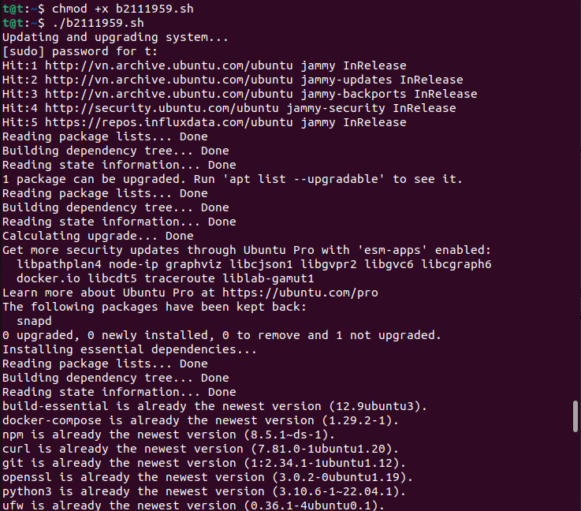

After run successfully
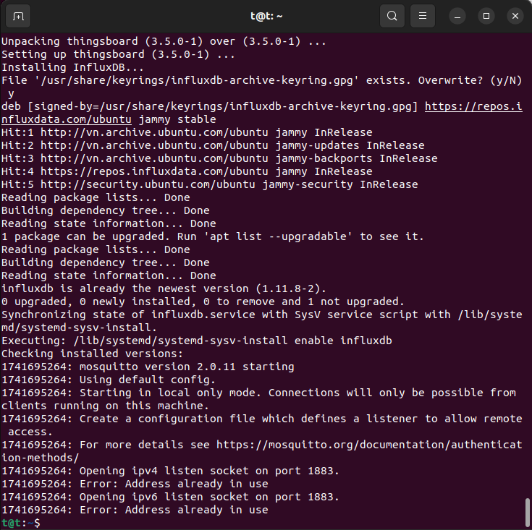
- IoT software setup environment/IDE (multiple choice possible)
- Design IoT software Architecture
Items | Resource
VM type | VirtualBox
OS | Ubuntu (Linux)
IP/URL
Language,version | Python (Latest Stable)
framework | Node.js
Libraries | Paho MQTT, requests, Flask, Express.js
Software tool | Node-RED, ThingsBoard
Protocol; | MQTT, CoAP
Message broker | Mosquitto
Software tool | InfluxDB, Grafana (for visualization)
Container | Docker, Docker Compose
Code Reference | GitHub repository or internal codebase

4. Explain IoT software installation process (write used resource)
This report outlines the process of installing and configuring essential IoT-related software on a Linux-based system. The installation is automated using a Bash script, ensuring consistency and efficiency in deployment. The process includes system updates, software installation, firewall configuration, and verification of installed components.
sudo apt update && sudo apt upgrade -y
This step updates package lists and installs the latest security patches and software versions.
Essential dependencies required for IoT operations are installed using the command:
sudo apt install -y curl wget git build-essential python3 python3-pip nodejs npm openssl ufw mosquitto mosquitto-clients docker.io docker-compose
The key components include:
- Development Tools: curl, wget, git, build-essential
- Programming Environments: Python3, pip, Node.js, npm
- Security & Network Tools: OpenSSL, UFW
- IoT Messaging Protocols: Mosquitto, Mosquitto-clients
- Containerization: Docker, Docker Compose
The firewall is configured to allow essential communication ports for IoT services:
sudo ufw allow 1883/tcp # MQTT
sudo ufw allow 8883/tcp # Secure MQTT
sudo ufw allow 5683/udp # CoAP
sudo ufw allow 8080/tcp # ThingsBoard Web UI
sudo ufw allow 8086/tcp # InfluxDB
sudo ufw enable
This ensures proper network communication for IoT devices while maintaining security.

Mosquitto is an MQTT message broker used for lightweight communication between IoT devices.
sudo systemctl enable mosquitto
sudo systemctl start mosquitto
Node-RED is a low-code development tool used for IoT automation.
sudo npm install -g --unsafe-perm node-red
ThingsBoard is an IoT platform for managing devices and visualizing sensor data.
wget -q https://github.com/thingsboard/thingsboard/releases/download/v3.5/thingsboard-3.5.deb
sudo dpkg -i thingsboard-3.5.deb
sudo systemctl enable thingsboard
sudo systemctl start thingsboard
InfluxDB is a database optimized for handling time-series data generated by IoT devices.
wget -qO- https://repos.influxdata.com/influxdata-archive_compat.key | sudo gpg --dearmor -o /usr/share/keyrings/influxdb-archive-keyring.gpg
echo "deb [signed-by=/usr/share/keyrings/influxdb-archive-keyring.gpg] https://repos.influxdata.com/ubuntu jammy stable" | sudo tee /etc/apt/sources.list.d/influxdb.list
sudo apt update && sudo apt install -y influxdb
sudo systemctl enable influxdb
sudo systemctl start influxdb
After installation, the script verifies the installed components by checking their versions:
mosquitto -v
node -v
npm -v
python3 --version
docker --version
influxd version
5.Execute your process and explain (write used resource)
System Update and Upgrade
The script first updates and upgrades the system. It checks for available updates from Ubuntu repositories and identifies that one package, snapd, has been kept back and not upgraded.
Installing Essential Dependencies
The script installs essential packages, but all the required packages, including build-essential, docker-compose, npm, curl, git, openssl, python3, ufw, wget, docker.io, mosquitto, mosquitto-clients, nodejs, and python3-pip, are already installed in their latest versions. No new packages are installed.
Configuring Firewall and Security Settings
The script configures the firewall (ufw), ensuring that necessary rules are in place. However, it skips adding rules that already exist. The firewall remains active and is enabled on system startup.
Enabling and Starting Mosquitto
Mosquitto, a message broker for MQTT, is enabled and started using systemctl. The script ensures that Mosquitto is set to start automatically upon system boot.
Installing Node-RED
The script attempts to install Node-RED using npm. However, several warnings (EBADENGINE) appear because the installed version of Node.js (v12.22.9) is outdated. Many dependencies, including node-red, fs-extra, mqtt, tar, and cacheable-request, require newer versions of Node.js (>=14, >=16, or >=18). Due to these version mismatches, the installation may not function correctly.

